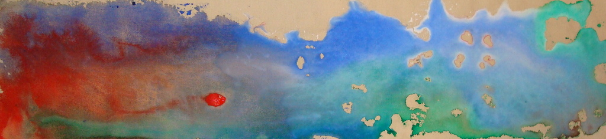
Title: Cosmos
Date: 2015
Medium: Acrylic on canvas
Dimensions: 8 by 38 inches
Price: $500.00

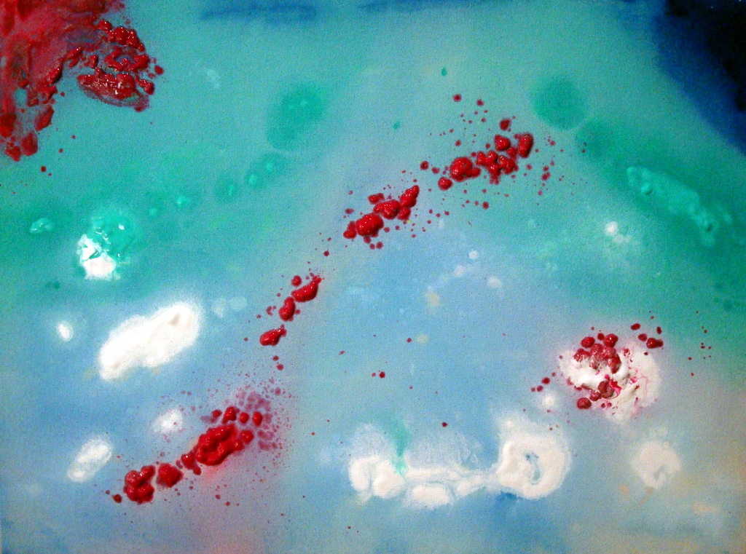
Title: Gleam
Date: 2016
Medium: Acrylic on canvas
Dimensions: 18 x 24 inches
Price: $650.00
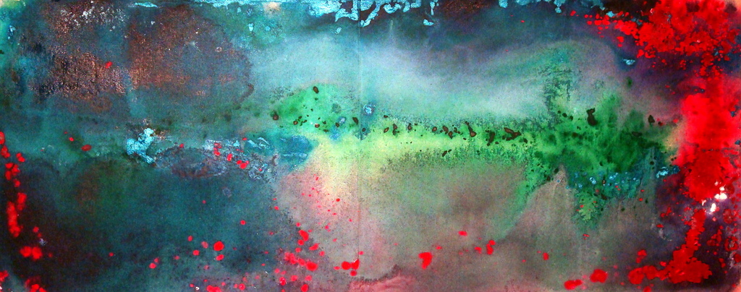
Title: Cluster
Date: 2016
Medium: Acrylic on canvas
Dimensions: 17 by 46 inches
Price: $1,200.00

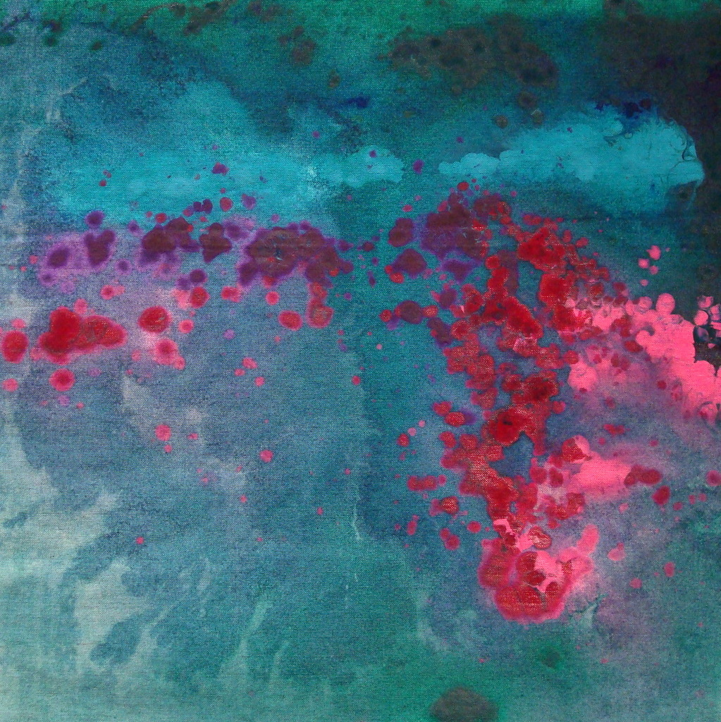
Title: Reef
Date: 2016
Medium: Acrylic on canvas
Dimensions: 18 by 18 inches
Price: $500.00


Title: Surface of the Sun
Date: 2016
Medium: Acrylic on canvas
Dimensions: 24 by 104 inches
Price: $3,800.00


Title: Dust
Date: 2016
Medium: Acrylic on canvas
Dimensions: 17 by 45 inches
Price: $1,150.00


Title: Lagoon
Date: 2016
Medium: Acrylic on canvas
Dimensions: 26 x 104 inches
Price: $4,100.00

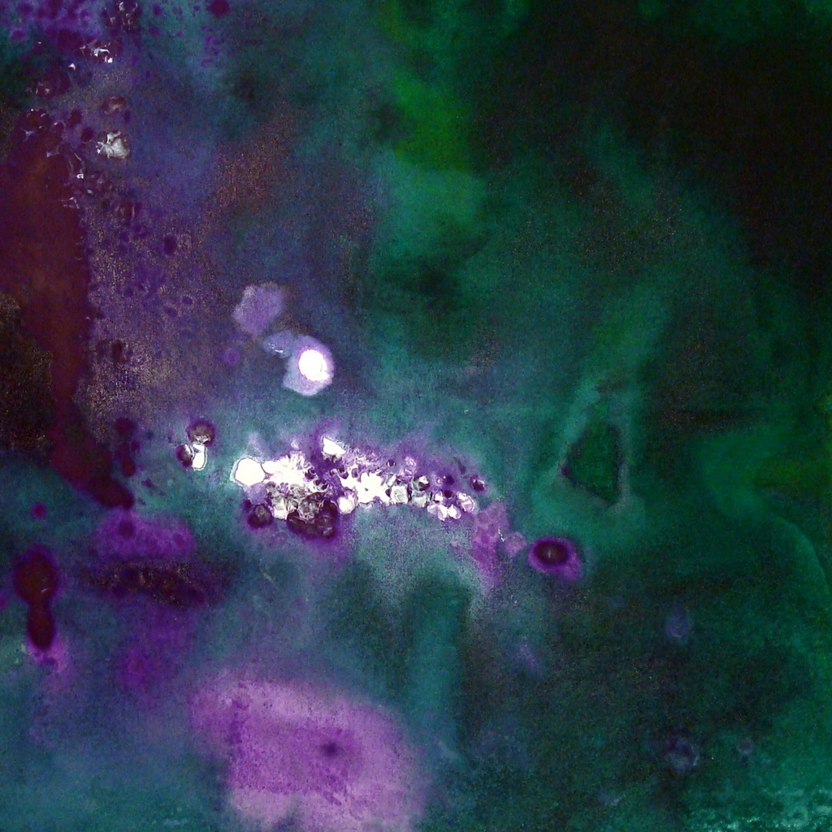
Title: Gathering
Date: 2016
Medium: Acrylic on canvas
Dimensions: 18 by 18 inches
Price: $500.00

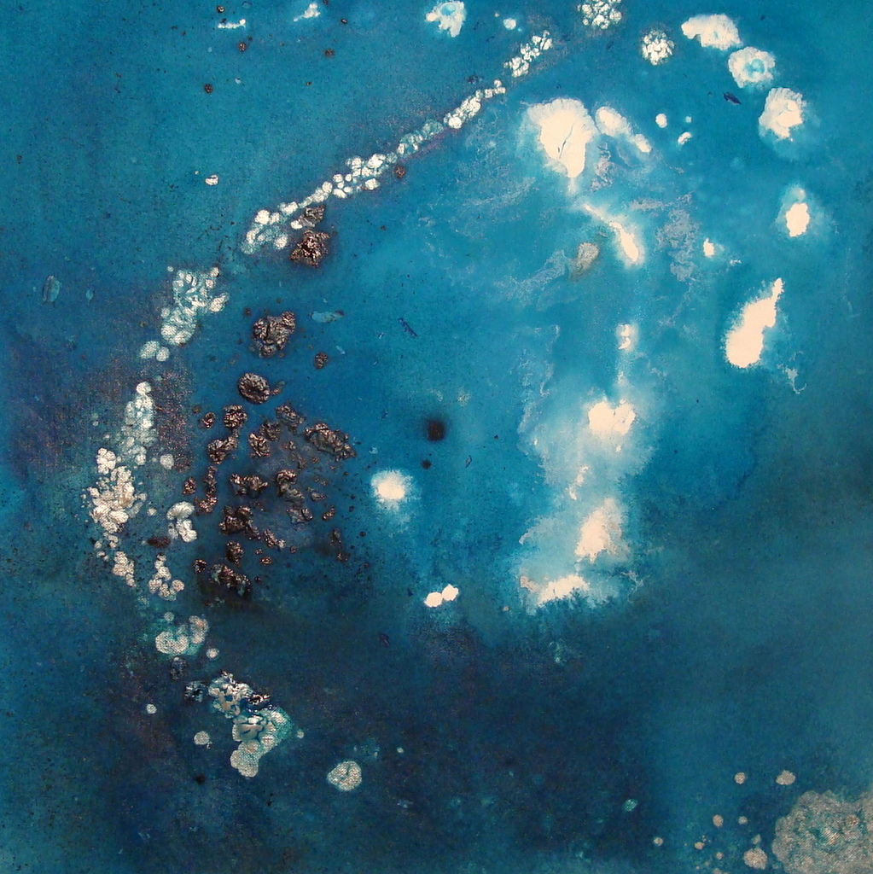
Title: Isolation
Date: 2016
Medium: Acrylic on canvas
Dimensions: 18 by 18 inches
Price: $500.00


Title: Summer Garden (for Simone)
Date: 2016
Medium: Acrylic on canvas
Dimensions: 18 by 18 inches
Price: $500.00

